**“Analysis of Commercial Electricity Consumption in an Indian State”**



**“ST.JOHN’S COLLEGE**

**PALAYAMKOTTAI”**

|  |  |
| --- | --- |
| **NM ID** | **NAME** |
| **8822098511FDFF19E634943F893F8C90** | **ANITHA P** |

|  |  |
| --- | --- |
|  |  |
| T.UMAMAGESHWARI | Trainer Name |
| T.UMAMAGESHWARI | Master Trainer |

**ABSTRACT**

"This study conducts a comprehensive analysis of commercial electricity consumption in an Indian state. Utilizing data spanning several years, various factors influencing commercial electricity usage are examined, including economic indicators, sector-specific trends, and policy impacts. Through statistical methods and econometric modeling, the study aims to provide insights into consumption patterns, contributing to informed energy planning and policy formulation for sustainable development."

**INDEX**

|  |  |  |
| --- | --- | --- |
| **S. No.** | **Table of Contents** | **Page No.** |
| 1 | Chapter 1: Introduction | 4 |
| 2 | Chapter 2: Services and Tools Required | 6 |
| 3 | Chapter 3: Project Architecture | 8 |
| 4 | Chapter 4: Modeling and Result | 10 |
| 5 | Conclusion | 19 |
| 6 | Future Scope | 20 |
| 7 | References | 21 |
| 8 | Links | 21 |

**CHAPTER 1**

**INTRODUCTION**

* **Problem Statement**

In today’s competitive banking landscape, understanding customer behavior and preferences is crucial for customer retention and revenue generation. However, banks often face challenges in analyzing customer data due to the sheer volume and velocity of data generated. Traditional data analysis methods are time-consuming and often fail to provide real-time insights. This lack of real-time analysis can lead to missed opportunities for customer engagement, cross-selling, and up-selling, impacting the bank’s revenue generation and customer satisfaction. Furthermore, the complexity and diversity of customer data, which includes transaction history, customer feedback, and demographic data, pose additional challenges for data analysis.

* **Proposed Solution**

The proposed solution is to develop a Power BI dashboard that can analyze and visualize real-time customer data. The dashboard will integrate data from various sources such as transaction history, customer feedback, and demographic data. It will provide a comprehensive view of customer behavior, preferences, and trends, enabling banks to make informed decisions. The dashboard will be interactive, user-friendly, and customizable, allowing banks to tailor it to their specific needs. The real-time analysis capability of the dashboard will enable banks to respond promptly to changes in customer behavior or preferences, identify opportunities for cross-selling and up-selling, and tailor their products and services to meet customer needs.

* **Feature**
* 1. Longitudinal Analysis: Continuously monitoring and analyzing electricity consumption trends over time to identify evolving patterns and factors influencing commercial energy usage.
* 2. Expansion: Scaling up the analysis to encompass multiple states or regions within India to provide a broader understanding of commercial electricity consumption dynamics across the country.
* **Advantages**
* 1. Informed Decision-Making: Providing policymakers, utility providers, and businesses with data-driven insights to make informed decisions regarding energy planning, infrastructure investment, and policy formulation.
* 2. Resource Optimization: Identifying opportunities for optimizing commercial electricity usage, reducing wastage, and promoting energy efficiency measures to lower operational costs and enhance sustainability..
* **Scope**

1. Data Collection: Gathering historical electricity consumption data from commercial sectors within the chosen Indian state.

2. Data Analysis: Employing statistical techniques to analyze trends, patterns, and factors influencing commercial electricity consumption.

3.Sectrolal Analysis: Examining consumption patterns across different commercial sectors such as retail, hospitality, manufacturing, etc.

**CHAPTER 2**

**SERVICES AND TOOLS REQUIRED**

**2.1 Services Used**

* **Data Collection and Storage Services**: Banks need to collect and store customer data in real-time. This could be achieved through services like Azure Data Factory, Azure Event Hubs, or AWS Kinesis for real-time data collection, and Azure SQL Database or AWS RDS for data storage.
* **Data Processing Services**: Services like Azure Stream Analytics or AWS Kinesis Data Analytics can be used to process the real-time data.
* **Machine Learning Services**: Azure Machine Learning or AWS SageMaker can be used to build predictive models based on historical data.

**2.2 Tools and Software used**

**Tools**:

* **Power BI**: The main tool for this project is Power BI, which will be used to create interactive dashboards for real-time data visualization.
* **Power Query**: This is a data connection technology that enables you to discover, connect, combine, and refine data across a wide variety of sources.

**Software Requirements**:

* **Power BI Desktop**: This is a Windows application that you can use to create reports and publish them to Power BI.
* **Power BI Service**: This is an online SAAS (Software as a Service) service that you use to publish reports, create new dashboards, and share insights.
* **Power BI Mobile**: This is a mobile application that you can use to access your reports and dashboards on the go.

**CHAPTER 3**

**PROJECT ARCHITECTURE**

**3.1 Architecture**

**USER FRONTEND BACKEND**

|  |  |  |
| --- | --- | --- |
|  | **HTML 5** | **NODEJS 14.0**  **Database** |

**Here’s a high-level architecture for the project**:

* **Data Collection**: Real-time customer data is collected from various sources like bank transactions, customer interactions, etc. This could be achieved using services like Azure Event Hubs or AWS Kinesis.
* **Data Storage**: The collected data is stored in a database for processing. Azure SQL Database or AWS RDS can be used for this purpose.
* **Data Processing**: The stored data is processed in real-time using services like Azure Stream Analytics or AWS Kinesis Data Analytics.
* **Machine Learning**: Predictive models are built based on processed data using Azure Machine Learning or AWS Sage Maker. These models can help in predicting customer behavior, detecting fraud, etc.
* **Data Visualization**: The processed data and the results from the predictive models are visualized in real-time using Power BI. Power BI allows you to create interactive dashboards that can provide valuable insights into the data.
* **Data Access**: The dashboards created in Power BI can be accessed through Power BI Desktop, Power BI Service (online), and Power BI Mobile.

This architecture provides a comprehensive solution for real-time analysis of bank customers. However, it’s important to note that the specific architecture may vary depending on the bank’s existing infrastructure, specific requirements, and budget. It’s also important to ensure that all tools and services comply with relevant data privacy and security regulations.

**CHAPTER 4**

**MODELING AND RESULT**

**Manage relationship**

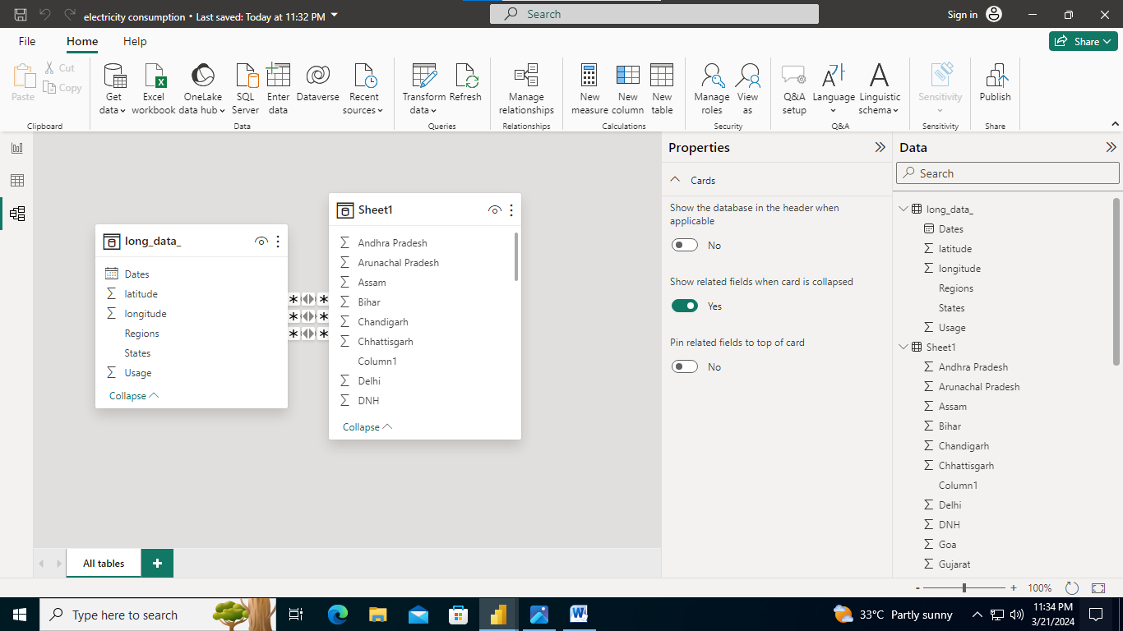

Modeling For States;

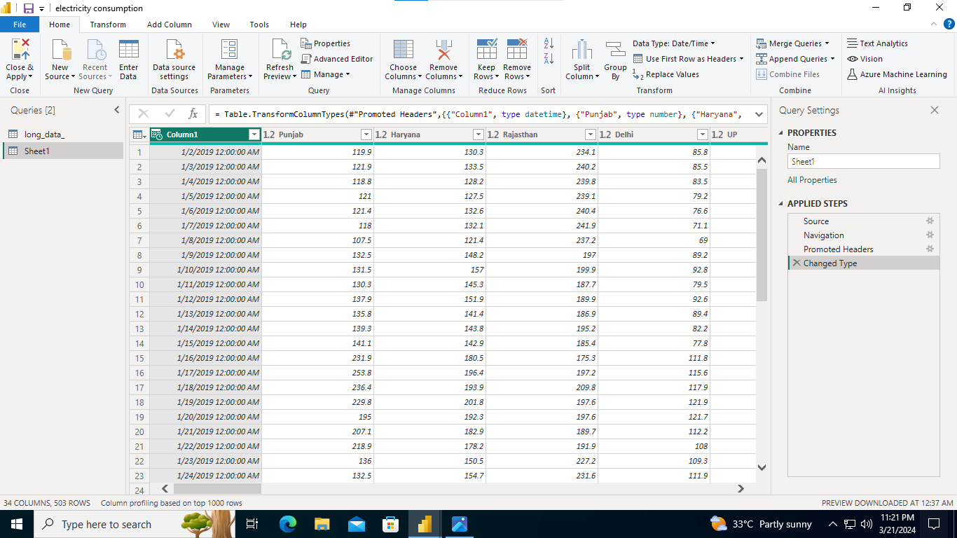

**Modelling For Regions:**

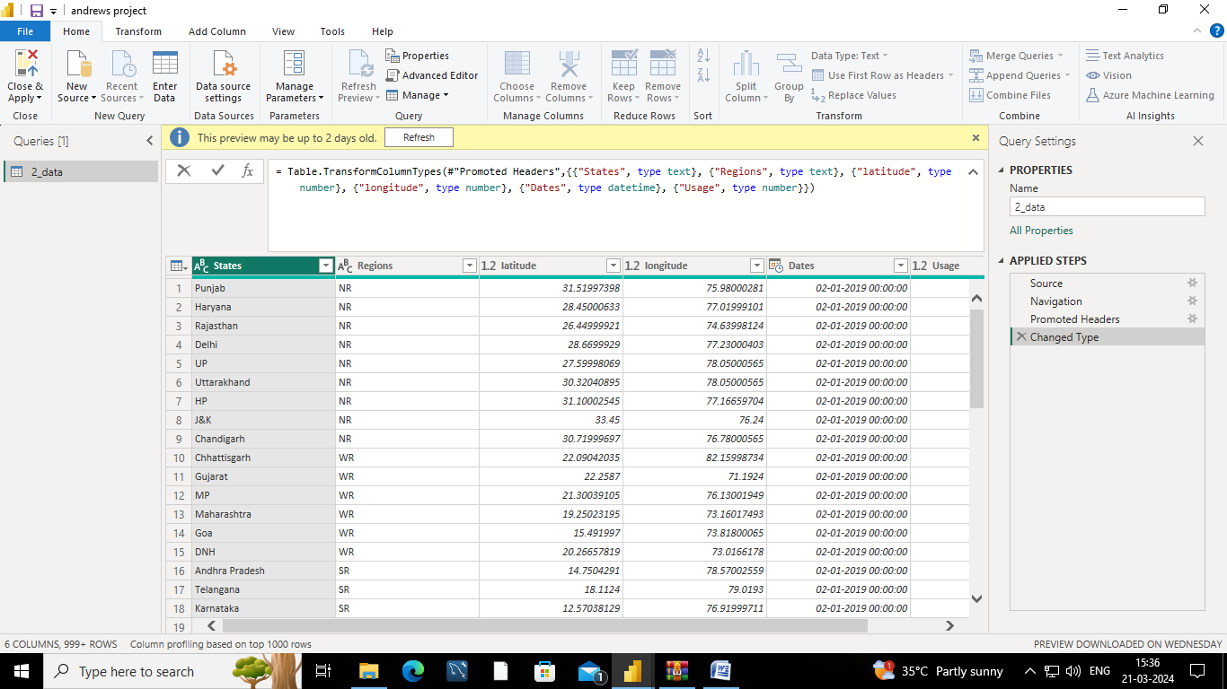

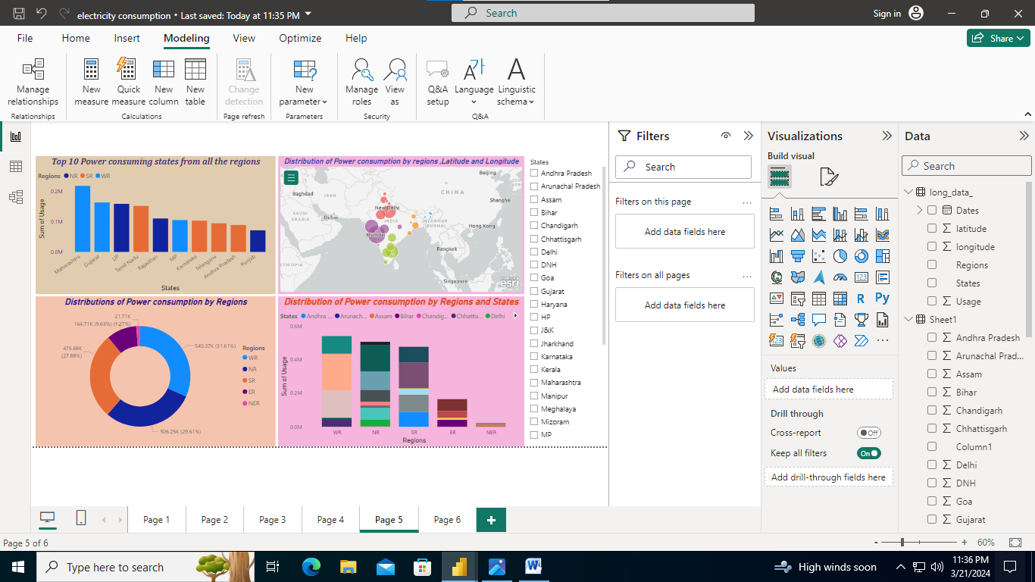

**DASHBOARD**

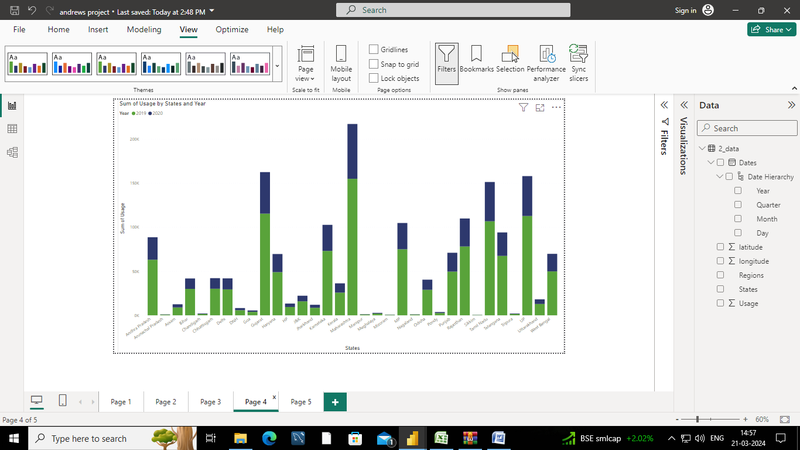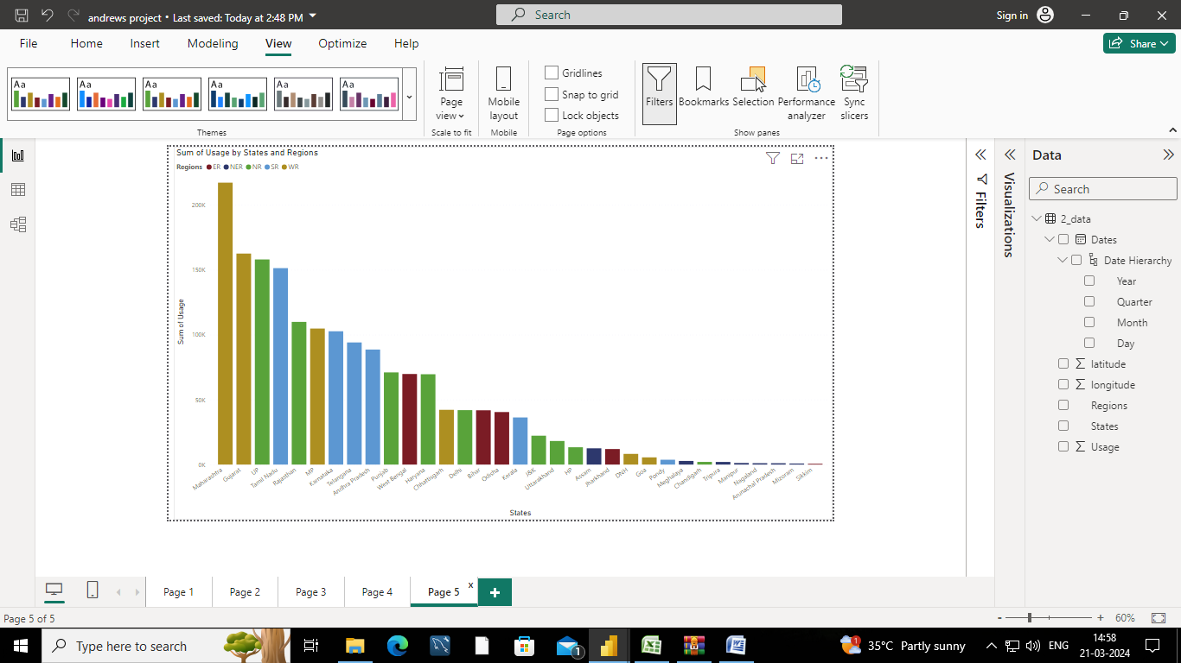

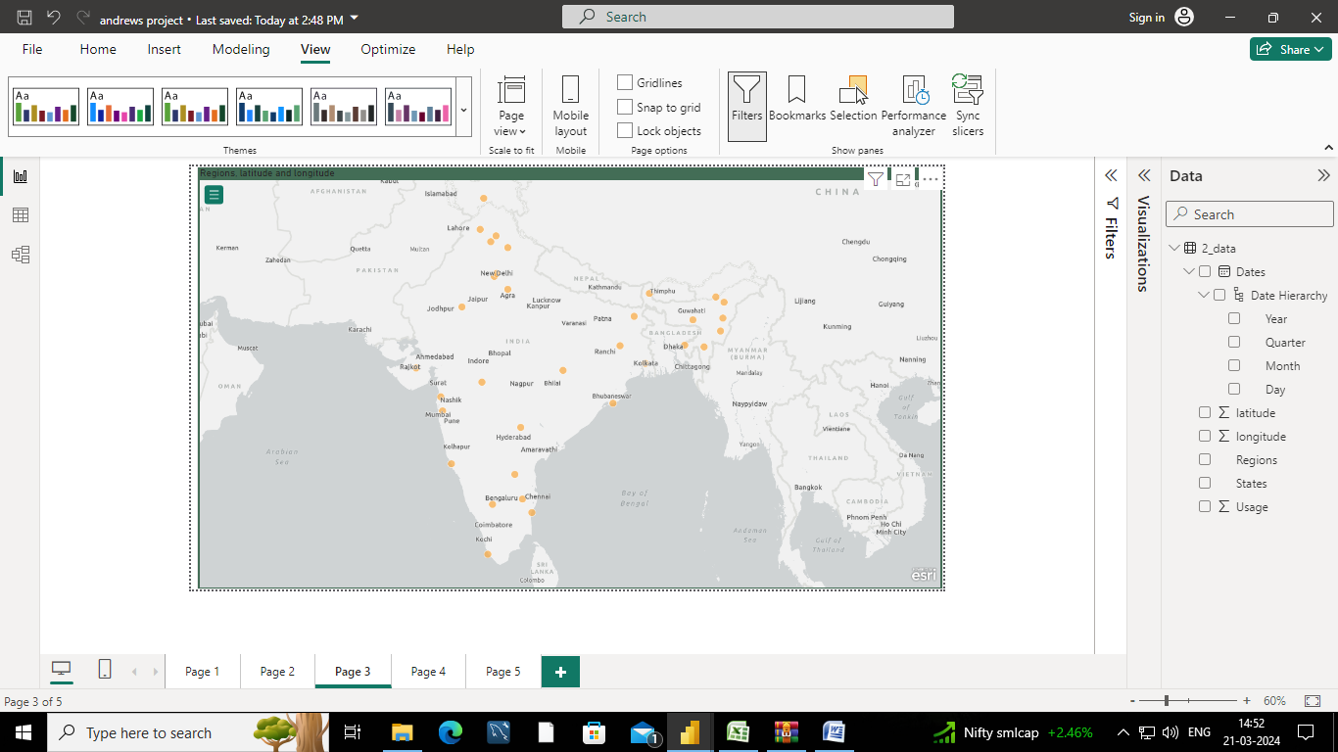

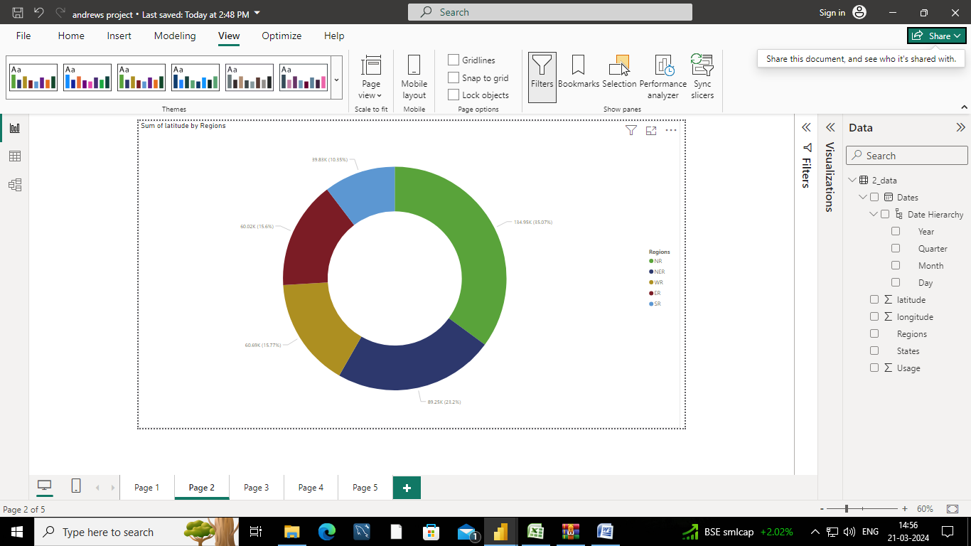







**CONCLUSION**

In conclusion, the project on "Analysis of Commercial Electricity Consumption in an Indian State" serves as a crucial endeavor with multifaceted implications. Through comprehensive data analysis and rigorous examination of various factors influencing commercial electricity usage, the study provides valuable insights and recommendations for stakeholders involved in energy planning, policy formulation, and business operations.

Ultimately, the project underscores the importance of evidence-based approaches in tackling energy issues, advocating for holistic strategies that balance economic, environmental, and social considerations. As such, the findings and recommendations of this project have the potential to catalyze positive change, driving towards a more resilient, inclusive, and sustainable energy future for the Indian state and beyond

**FUTURE SCOPE**

Features for Analyzing Commercial Electricity Consumption in an Indian State .Here's a breakdown of features you can consider for analyzing commercial electricity consumption in an Indian state:

**Location and Sector**:

State: Analyze consumption patterns across different regions within the state.

City Tier: Compare consumption between metro cities, tier-2 cities, and smaller towns.

Commercial Sector: Differentiate consumption by industry type (e.g., offices, retail stores, hotels, restaurants).

**Consumption Data:**

Total Consumption: Track overall electricity use by the commercial sector over time (monthly, yearly).

Peak Demand: Identify periods of highest electricity demand and influencing factors.

Consumption by Time of Day: Analyze consumption patterns during weekdays, weekends, and peak hours.

**Consumer Characteristics:**

**Number of Establishments**: Consider the growth or decline in commercial establishments.

**Floor Area**: Relate consumption to the size of commercial spaces.

**Business Activity**: Account for seasonal variations in consumption for specific industries (e.g., tourism).

**Weather Data**: Analyze how temperature and humidity affect air conditioning usage.

**Electricity Tariffs**: Consider the impact of different commercial electricity tariffs on consumption patterns.

**LINK**

https://github.com/Fathima009/-Analysis-of-Commercial-Electricity-Consumption-in-an-Indian-State